Canyon Creek PTA Advocacy Report

September/October 2022

Recent and Upcoming Key Advocacy Dates
- Monday, September 12, NSD School Board Meeting: Video Available
- Tuesday, September 27, NSD School Board Meeting: Video Available
- Monday, October 10: NSD School Board Meeting, 4:00-5:30pm, 3330 Monte Villa Pkwy, Bothell, WA 98021
- Saturday and Sunday, October 15-16: 2022 WSPTA Legislative Assembly, Bellevue College or Online (Whova App)
- Monday, October 17: Conversations with the Board, 6:00-7:30pm, NSD Administrative Office, 3330 Monte Villa Pkwy, Bothell, WA 98021
- Monday, October 25: NSD School Board Meeting, 7:00-8:30pm, 3330 Monte Villa Pkwy, Bothell, WA 98021

44th Annual WSPTA Legislative Assembly

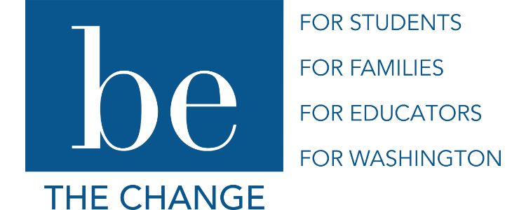
What is Legislative Assembly?
The WSPTA Legislative Assembly is about participation. PTA members submit new positions to be added to WSPTA’s policy platform, volunteers on the advocacy committee, resolutions committee and board of directors review them, and delegates at legislative assembly amend, debate and vote on whether to adopt them.
This year, WSPTA is planning for the legislative assembly to be a hybrid event for more inclusive participation. Delegates will be able to attend and vote in person at Bellevue College or remotely. To learn more about this year’s event watch this video. Voting delegates will caucus and vote on the Washington State PTA Legislative Platform.
What is a legislative platform?
The Washington State PTA legislative platform is a two-year platform to mirror the Washington state legislative cycle. In the even-numbered years, the new platform is voted on by members at the legislative assembly in the fall. The top five issues become our short-term platform and consist of our priority issues when advocating throughout the year. Other issues are placed on an “also supported” list.
During the odd-numbered years, members vote to amend current issues or to add new, emerging issues to the also supported list. There are five legislative priorities on the platform, and three supported issues. To learn more about each of the priorities and supported issues click here. A full playlist of issue education videos is also available on the WSPTA YouTube channel.
What will the 2023-2024 Legislative Platform be?
During this year’s Legislative Assembly, delegates will be voting to rank priorities for the legislative platform. There are 13 issues up for discussion and voting. The top five issues that emerge will be the legislative priorities for the WSPTA for the next two years. Here is the 2022 Voter’s Guide for Legislative Issues to learn more.
Your Voice Matters!
Let your PTA delegate know what issues are important to you and the Canyon Creek school community, as well as to students across the state.
Take this poll to give the WSPTA some input before Legislative Assembly. Fill out and return by Monday, October 10th.

Attend NSD School Board Meetings!
Have you ever attended a school board meeting? They can be quite informative and insightful as to the happenings in our district. The below dates are held in person (NSD 3330 Monte Villa Pkwy, Bothell) or can be watched later on once the session is recorded.
- Monday, October 10th, 4-5:30pm
- Monday, October 25th, 7-8:30pm
Meetings are usually held on the second Monday of the month at 4 p.m. and the fourth Monday of the month at 7 p.m. Click here for School Board meeting schedule and info about how to attend a meeting.
Click here for Past meetings and documents.

NSD 2022-2023 Listen and Learn Tour
Between August and December 2022, Interim Superintendent Tolley will be implementing a comprehensive Listen and Learn tour.
The purpose of the tour is to introduce stakeholders, including staff, to the refreshed five-year Strategic Plan, grow Interim Superintendent Tolley’s knowledge of the District, and provide an intentional and inclusive structure for two-way communication with the Northshore School District community and stakeholders.
Learn more about the Listen and Learn Tour here.

NSD Bond Updates: School Expansion and Renovation Projects in Pre-planning Stage
The District Capital Projects Office has been in the pre-planning stage for projects since the approval of the 2022 Capital Bond in February. The Capital Bond included expansions or modernizations to support student learning in eight schools in the Northshore School District, including Sorenson Early Childhood Center, Crystal Springs, Fernwood, Woodin, Maywood Hills and Kenmore elementaries, Leota Middle School, and Inglemoor High School.
The design and construction projects are being grouped based on building needs and similarities into four bundles: Elementary/Early Learning Expansions; Elementary Modernizations/Additions; Leota Middle School Design and Phase I Construction; Inglemoor High School Design and Phase I Construction. Learn more details on these project groupings here.
This work is made possible by the generous support of Northshore voters, who approved the 2022 bond in support of our children.

PTA Advocates for All Children
Did you know that PTA is the oldest and largest child advocacy organization in the country? Since inception in 1905, PTA has been a driving force behind the creation of kindergarten, hot lunch programs, early education, and so much more. PTA advocates on behalf of all children on the important issues impacting education, health, and safety.
PTA Advocacy can be as simple as being informed on the issues or can be expanded to include attending and speaking at school board meetings, sending letters and meeting with your legislators, attending the PTA Focus Day Rally, or testifying in front of the state legislature to put a face on important issues.
Join or renew your Canyon Creek PTA membership today!
Subscribe to WSPTA’s Action Network Group!
Learn more about Washington State PTA by visiting their website at https://www.wastatepta.org/about/.
Learn more about National PTA by visiting their website at https://www.pta.org/.

Learn More!
For more information about PTA Advocacy and Legislation in general, local representatives, the 2020-2022 platform, and upcoming events for the year, please see our PTA Advocacy & Legislation page.
____________________________________________________

Submitted by: Erika Del Villar, Canyon Creek PTA Advocacy Chair

