Spring PTA STEM Fair
Tuesday, April 24, 6-8pm, Canyon Creek Gym

The Canyon Creek Spring Science, Technology, Engineering, and Math (STEM) Science Fair will be an opportunity for you to learn about a STEM-related topic and present it to your peers, parents, and teachers. Choose from a variety of project ideas: you can conduct an experiment, research a favorite scientist or a STEM-related topic, create a diorama about a topic that interests you, build a machine or a robot, or create your own code. The opportunities are truly endless. Let’s have fun and get excited about STEM!
Some examples of STEM fair projects:
- Create a diorama of an ecosystem, tectonic plates, an engine, or the solar system
- Create a display to teach others about a favorite scientist, how levers work, why the refrigerator is cold, how the human eye can see, or the parts of a flower
- Engineer a machine and demonstrate how and why it works
- Really, your project can be about anything STEM-related that interests you!
Examples of STEM experiments*:
- Can plants grow in pots if they are sideways or upside down?
- Does the color of hair affect how much static electricity it can carry? (test with balloons)
- How much weight can the surface tension of water hold?
- Can some people really read someone else’s thoughts?
- Which soda decays fallen out teeth the most?
- What light brightness makes plants grow the best?
- Does the color of birdseed affect how much birds will eat it?
- Do natural or chemical fertilizers work best?
- Can mice learn? (you can pick any animal)
- Can people tell artificial smells from real ones?
- What brands of bubble gum produce the biggest bubbles?
- Does age affect human reaction times?
- What is the effect of salt on the boiling temperature of water?
- What type of grass seed grows the fastest?
- Can animals see in the dark better than humans?
*These ideas and more can be found on the www.sciencebob.com website.
Find all the details and links to other project ideas and resources on our website:
http://canyoncreekpta.org/Article/View/STEM-Fair-April-24th
These activities are not sponsored nor endorsed by the Northshore School District or any of its schools. The district assumes no responsibility for the conduct during or safety of the activities. Northshore School District shall be held harmless from any cause of action, claim, or petition filed in any court or administrative tribunal arising out of the distribution of these materials including attorney's fees and judgments or awards.
If you choose to conduct a STEM experiment, be sure to include the following elements on your display board: a title, a problem statement, background information/literature, a hypothesis, materials, procedure, results, and a conclusion.
Title: Choose a title that tells what your project is about, and gets the viewer’s attention.
Example: “Plant Problems”
Problem statement: Choose a topic that can only be answered through experimenting. Your topic is a question that will be investigated. Example: “Does soil type affect plant growth?”
Background Information/Literature: Read books and articles on your subject in order to better understand your problem. Also, interview and talk with people who are knowledgeable about your subject. Once you have collected information, write a summary in your own words that includes all the information you gathered. Do not copy any information directly from any source. Then list your sources in alphabetical order.
Hypothesis: A hypothesis states what you predict will happen when you conduct your experiment. Example: “If pole beans are planted in three pots with potting soil, sand, or compost, they will grow the tallest in the pot with compost.”
Materials: List the materials used in your investigation. Include details such as size and quantity. Example:
- Nine pole bean seeds (three for each pot)
- Three ½-gallon plastic pots
- 1/3-gallon each sand, compost, and potting soil
Procedure: Write a step-by-step description of how you conducted your experiment. You want the procedure to be so clear and complete that others can duplicate it exactly.
Example:
Three identical ½-gallon plastic pots were filled with exactly 1/3-gallon each of sand, compost and potting soil. Three pole bean seeds were planted in each pot, evenly spaced from each other, and at a depth of ½ inch. All three pots were placed in a south-facing window, and each received the same amount of sunlight throughout the day. Every Monday, Wednesday, and Friday morning each plant was given 1/8 cup of water. On Mondays and Fridays, the height of each plant was measured in centimeters and recorded in a log book.
Data: Write down the information you learned throughout your experiment.
Example: The measurements of plant heights

Continued on the back
Results: Discuss what the data means and whether or not it matches your hypothesis.
Example: The plant in the potting soil grew taller than the plant in the compost. The plant in the sand did not grow at all. I learned that soil type does affect plant growth. However, my hypothesis that the plant would grow the tallest in compost was incorrect. In fact, the tallest plant at the end of my experiment was grown in potting soil.
Conclusion: Answer your problem/purpose statement. What does it all add up to? What did you learn from your project? Example: Soil type does affect plant growth. Plants need soil to grow, and cannot grow in sand.
Your poster should look something like this:

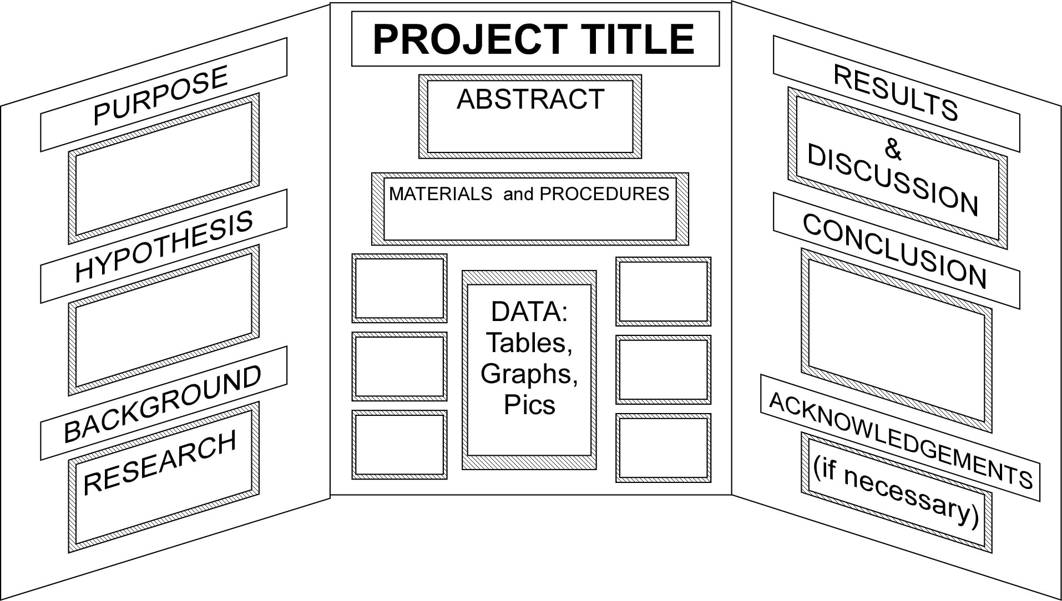

These activities are not sponsored nor endorsed by the Northshore School District or any of its schools. The district assumes no responsibility for the conduct during or safety of the activities. Northshore School District shall be held harmless from any cause of action, claim, or petition filed in any court or administrative tribunal arising out of the distribution of these materials including attorney's fees and judgments or awards.

